Knowledge & Technology
Bangladesh Army University of Engineering & Technology (BAUET)
Qadirabad Cantonment, Natore-6431


DEPARTMENT OF
COMPUTER SCIENCE AND ENGINEERING (CSE)
PROJECT PROPOSAL

Course Code : CSE-3102
Course Tittle : Software Engineering and Information Design
Laboratory

Project Name : Alumni Management Portal (Alumni Association)
Date of Submission : 13.11.2025

Submitted To
Tanvir Anjom Siddique
Lecturer
Dept. of CSE, BAUET
Awaleen Nawar Suha
Lecturer
Dept. of CSE, BAUET

Submitted By
Name : Md. Muhiminul Islam
ID : 0812310205101006
Name : Zarif Ahnaf Dhrubo
ID : 0812310205101023
Name : Khondokar Mishkatul Azim
ID : 0812310205101028
Batch : 17th
Year : 3rd
Semester : 1st
Section : A2
Session : 2022-2023

- Abstract
This proposal outlines the development of an Alumni Management Portal, “Alumni Association” to strengthen engagement between alumni and the institution. The portal will serve as a centralized platform for maintaining alumni records, organizing events, sharing updates, and enabling alumni to connect with one another and current students. This initiative aims to foster long-term relationships, enhance networking opportunities, and streamline alumni-related communications.

- Platform
The Alumni Association System is a multi-platform web application, designed to function efficiently on both desktop and mobile devices. With responsive design principles, the interface provides intuitive navigation and accessibility across all major browsers and operating systems. The system architecture is modular, allowing future enhancements and integration with external services such as professional networking platforms or other APIs.

- Background
- Problem Statement
Despite the growing importance of alumni engagement, many educational institutions struggle to maintain strong and consistent connections with their graduates. Traditional methods such as spreadsheets, informal social media groups, and outdated databases are inefficient, prone to errors, and lack scalability. As a result, institutions face difficulties in:

  - Keeping alumni contact information up to date
  - Organizing and promoting alumni events
  - Sharing news, job opportunities, and institutional updates
  - Encouraging alumni to participate in mentoring, donations, and networking

Without a centralized and user-friendly system, valuable opportunities for collaboration, support, and community building are lost. To bridge this gap, there is a need for a modern, secure, and accessible Alumni Management Portal that can streamline communication, automate administrative tasks, and enhance long-term alumni engagement.

- Introduction
Alumni play a crucial role in the long-term success and reputation of any educational institution. They serve not only as ambassadors of the institution but also as valuable contributors in areas such as career mentoring, guest lectures, fundraising, and student support. However, maintaining consistent communication and engagement with alumni can be challenging without a centralized, modern system.

To address these challenges, this proposal recommends the development of an Alumni Management Portal: A dedicated web-based platform designed to streamline alumni data management, facilitate event coordination, and strengthen alumni-institution and alumni-to-alumni connections.

- Objectives
The primary goal of this project is to design and develop an Alumni Management Portal that enhances the relationship between the institution and its alumni. The portal will provide a centralized, user-friendly platform to manage alumni data, encourage engagement, and support institutional growth. The key objectives of this project are:

- To build a secure, web-based portal for alumni registration, login, and profile management
- To maintain a centralized and searchable alumni database with filtering options
- To enable the institution to post announcements, news, and updates targeted to alumni
- To facilitate event creation, management, and RSVP tracking for reunions, webinars, and other programs
- To provide a job board where alumni can share or access career opportunities
- To create networking features that allow alumni to connect with each other and with current students
- To develop an admin dashboard for managing content, users, and analytics
- To ensure data privacy and security through encryption, authentication, and access .control
- To offer mobile responsiveness for easy access on all devices

These objectives aim to promote active alumni involvement while reducing administrative workload through automation and centralization.

- Methodology
The development will follow an agile process with iterative feedback. For easier understanding and planning, this section is divided into separate modules as follows:

- Planning Phase
The Planning Phase is a critical step in ensuring the smooth execution of the Alumni Management Portal project. It involves defining a clear roadmap, identifying project milestones, assigning responsibilities, and preparing resources before actual development begins. This phase lays the foundation for coordination, risk management, and timely delivery.

This phase includes:

    - Development Roadmap
    - Team Formation and Role Assignment
    - Technology Stack Finalization
    - Risk Planning and Mitigation Strategies
    - Timeline and Budget Confirmation

- Feasibility Study and Cost Benefit Analysis Phase
The Feasibility and Cost–Benefit Analysis Phase evaluates whether the Alumni Management Portal can be developed and implemented effectively within the given constraints. It focuses on analyzing the technical, operational, and economic feasibility of the project, along with assessing the costs and expected benefits to determine its overall viability. This phase ensures that development efforts are directed toward a practical, cost-effective, and sustainable system that delivers measurable value to the institution.

Through a detailed cost–benefit analysis, both tangible and intangible benefits are compared against estimated development, implementation, and maintenance costs. This helps justify resource allocation and confirms whether the project will yield a positive return on investment (ROI).

This phase includes:

- Feasibility Study
- Cost-Benefit Analysis
- Identifying Characteristics of Candidate System
- Performance and Cost Effectiveness
- Weighting the Best Candidate System
- Selecting the Best Candidate System

- Requirement Analysis Phase
The Requirement Analysis phase is focused on identifying, gathering, and validating all functional and non-functional requirements necessary for the successful development of the Alumni Management Portal. This phase ensures that the final product meets the needs of the institution, its alumni, and administrative stakeholders.

This phase includes:

- Stakeholder Identification
- Functional Requirements
- Non-Functional Requirements
- Data Requirements
- Integration Requirements
- System Modeling

Introduction

A Gantt chart is a visual project management tool that illustrates a project schedule, showing tasks, their durations, and dependencies over time. In your alumni management association project, it helps plan and track development phases, like user registration, event management, or mentorship features—ensuring timely progress. It also clarifies team responsibilities and deadlines, improving coordination among developers, designers, and stakeholders. This keeps the project on schedule and aligns efforts toward key milestones.

This table represents the monthly timeline followed during the project. Each task was divided into phases to ensure smooth and organized progress. The plan helped track which stage the team was working on in each month and made it easier to balance time and workload across all activities.

Task / Month | 1st | 2nd | 3rd | 4th | 5th | 6th
Planning
Requirement Analysis
Development
Testing
Deployment
Other

Fig.12.1: Project Scheduling Gantt Chant

Description
In the first month, the team focused mainly on planning and requirement analysis, where project goals, needed resources, and user requirements were discussed and finalized.
From the second to the fourth month, the development phase took place. During this time, the actual system was built, tested locally, and refined according to the planned structure and design.
By the fifth month, attention shifted toward testing, identifying and fixing errors to ensure system stability. Finally, in the sixth month, the project reached the deployment stage, where the system was finalized, deployed, and prepared for demonstration or real-world use.

Short Summary
Month 1 : Finalized project goals, resources, and user needs.
Months 2–4 : Built, tested locally, and refined the system per design.
Month 5 : Identified and fixed bugs to ensure stability.
Month 6 : Deployed final system and prepared for demo/real use

Conclusion
The month-wise plan helped the team stay organized and maintain steady progress throughout the project. Each phase built upon the previous one, leading to a well-structured and functioning final product. This systematic approach ensured that all major aspects—from planning to deployment—were completed efficiently and on time.

- Risk Planning and Mitigation Strategies
Some common risks are
- Stakeholders may request new features mid-project, increasing workload and delaying delivery
- Unforeseen integration issues, bugs, or performance bottlenecks during development.
- Data Privacy and Security Breach
- Delayed Deliverables
- Poor User Adoption
- Hosting or Deployment Failures
- Post-Launch Maintenance Risk
Mitigation Strategies
- Define clear requirements and freeze scope early, allocate a contingency buffer for unexpected scope changes
- Implement strong encryption, authentication, and access control, conduct security audits and penetration testing
- Use project management tools (e.g., Trello, Jira).
- Focus on intuitive UI/UX design
- Conduct pre-deployment testing in a staging environment
- Plan for annual maintenance and support in the budget, train internal staff or contract external vendors for ongoing support

- Timeline and Budget Confirmation
Timeline is well defined in Development Roadmap (Module 1, Section a)

Table-1.1: Budget Estimation
Budget Category | Estimated Cost (BDT) | Estimated Cost (USD)
Design (UI/UX) | 40,000/- | $400
Development | 300,000/- | $3,000
Testing & QA | 30,000/- | $300
Deployment (Server + Setup) | 20,000/- | $200
Maintenance (6 Months) | 45,000/- | $450
Promotion & Awareness | 10,000/- | $100
Project Management | 20,000/- | $200
Contingency | 35,000/- | $350
TOTAL | 500,000/- | $5,000

Module 2
Feasibility Study and Cost Benefit Analysis Phase
Introduction
Cost-Benefit Analysis (CBA) is a systematic approach used to evaluate the financial and non-financial impacts of a project, decision, or investment. It involves comparing the total expected costs against the anticipated benefits to determine whether the outcome is worthwhile. By quantifying both tangible and intangible factors, CBA helps decision-makers assess feasibility, prioritize options, and ensure efficient resource allocation.

- Feasibility Study
The Feasibility Study examines the Alumni Management Portal project from multiple perspectives to ensure its successful implementation.

Technical Feasibility
Assesses whether the required technologies, tools, and infrastructure are available and capable of supporting the portal’s development and operation.

Operational Feasibility
Evaluates whether the system can be effectively integrated into the institution’s existing processes, ensuring ease of use for administrators, faculty, and alumni.

Economic Feasibility
Analyzes the estimated costs for development, deployment, and maintenance against the expected benefits, ensuring that the project delivers value for investment.

Schedule Feasibility
Determines whether the proposed timeline can realistically accommodate all development phases without compromising quality.

- Cost-Benefit Analysis
The Cost Benefit Analysis evaluates the financial feasibility and overall value of developing and implementing the Alumni Management Portal. It compares the estimated costs of system development, deployment, and maintenance with the expected benefits the portal will bring to the institution and its stakeholders.

- Tangible Costs
Tangible costs refer to the measurable financial expenses directly associated with the development and operation of the Alumni Management Portal. These include design, development, deployment, maintenance, and related resource expenditures.

Table-7.1: Tangible Cost Breakdown
Cost Category | Description | Estimated Cost (BDT)
Design (UI/UX) | Interface and layout design, user experience testing | 40,000/-
Development | Backend and frontend coding, database integration | 300,000/-
Testing & QA | Functional, integration, and security testing | 30,000/-
Deployment | Server setup, hosting, domain registration | 20,000/-
Maintenance (6 Months) | Bug fixing, updates, technical support | 45,000/-
Promotion & Awareness | Advertising and social media outreach | 10,000/-
Project Management & Contingency | Supervision, monitoring, risk buffer | 55,000/-
Total Tangible Cost |  | 500,000/-

- Intangible Costs
Intangible costs are non-physical but impactful expenses related to time, effort, and opportunity. These may not be directly measurable but contribute significantly to the overall cost of the project.

The possible intangible costs for the project are:
- Time spent by staff and developers during meetings and reviews
- Learning curve for administrators adapting to the new system
- Temporary disruption during transition from manual to digital management
- Potential resistance or low initial adoption by some users

- Direct Costs
Direct costs are those that are immediately linked to the portal’s development and operation.

These include:
- Software tools, frameworks, and database hosting services
- Developer and designer labor costs
- Testing equipment and server setup
- Maintenance and support contracts

- Indirect Costs
Indirect costs support the project indirectly but are necessary for overall completion and sustainability.

Examples include:
- Electricity and internet usage during development
- Training sessions and workshops for staff and alumni users
- Administrative overhead and coordination expenses
- Institutional IT resource utilization

- Payback Period Analysis
The Payback Analysis determines how long it will take for the benefits of the system to recover the initial investment.

Given below is an estimate:
Table-7.2: Payback Analysis Estimate
Year | Cumulative Cost (BDT) | Cumulative Benefit (BDT) | Net Benefit (BDT) | Remarks
01 | 200,000/- | 60,000/- | -140,000/- | Initial development, deployment, and setup
02 | 260,000/- | 150,000/- | -110,000/- | Hosting, support, user onboarding
03 | 310,000/- | 260,000/- | -50,000/- | Feature improvements, marketing, engagement
04 | 340,000/- | 390,000/- | 50,000/- | System stabilization, wider participation
05 | 370,000/- | 540,000/- | +170,000/- | Maintenance and full operational maturity
06 | 410,000/- | 670,000/- | +260,000/- | Payback has been achieved

Fig.2.1: Payback Analysis Graph

Conclusion
The cumulative cost-benefit analysis over the six-year period clearly demonstrates the financial viability and strategic value of the project. Initially, in the first three years, the project incurred higher costs than benefits, reflecting the significant investment required for development, deployment, user onboarding, and marketing activities. Specifically, in Year 1, the system faced a substantial net loss of BDT 140,000 due to initial setup and development expenses, which is typical for innovative initiatives requiring upfront infrastructure and operational readiness.
By Year 4, the system began generating net positive benefits, with a net gain of BDT 50,000, indicating the onset of operational effectiveness and wider user adoption. This upward trend continued into Years 5 and 6, where the net benefits rose sharply to BDT 170,000 and BDT 260,000, respectively. The financial performance in these years highlights that the project reached full operational maturity, with costs stabilizing and benefits increasing steadily due to sustained engagement, optimized operations, and efficient resource management.
Crucially, the analysis shows that payback was achieved in Year 6, marking a turning point where cumulative benefits surpassed cumulative costs. This milestone confirms the long-term sustainability of the project and validates the initial investment. Beyond financial returns, the staged growth also indicates that the project successfully transitioned from a development-focused phase to a mature, self-sustaining system capable of generating measurable value for stakeholders.

- Identifying Characteristics of Candidate System
In this section, different possible system approaches for developing the Alumni Management Portal are explored and analyzed. Each candidate system is described in terms of its structure, functionality, required technologies, and level of integration with existing institutional systems. By identifying these characteristics, the project team can compare multiple alternatives and understand their potential impact on users, performance, and long-term scalability.

Table-7.3: Characteristics of the Existing System and Two Potential Candidate Systems
Features | Existing System | Candidate System 1 | Candidate System 2
User Profile | Manual paper forms | Basic digital profile (admin-managed) | Self-managed digital profile with validation
Mentorship & Networking Features | None (word-of-mouth only) | Email-based matching | AI-driven interest & industry-based matching
Event Management | Paper notices; verbal invitation | Static web calendar + email invitation | Integrated calendar with auto-reminders & tracking
Career Opportunities | Occasional WhatsApp/email forwards | PDF job posts on notice board | Interactive job portal with alerts & apps
News Sharing | Occasional newsletters | Admin blog on basic website | Alumni-submitted articles with moderation
Security & Token Management | No login system | Session-based authentication | JWT + OAuth 2.0 with role-based access
Authentication Flexibility | N/A | Email + password | Multi-factor (Email, OTP, Google SSO)
Audit Logging & Activity Tracking | None | Basic login/logout logs | Full activity trail (edits, views, sign-ups)
Scheduled Tasks | Manual reminders | None | Automated emails, backups, reminders
Mobile Responsiveness | No website or non-responsive | Responsive static site | PWA + RESTful API
Departmental & Group Organization | Fixed by graduation year (spreadsheet) | Static groups by batch | Dynamic Groups (interest/location/field)
Cost Efficiency | Low tech cost, high manual labor | Moderate dev cost, low automation | Higher dev cost, minimal long-term cost

- Performance and Cost Effectiveness
This section focuses on evaluating each candidate system based on its expected performance and cost efficiency. Key factors such as system speed, reliability, scalability, maintenance requirements, and resource utilization are assessed alongside initial development costs, operational expenses, and future maintenance costs. The goal is to identify a solution that delivers strong performance while remaining financially sustainable for the institution.

Table 7.4: Qualitative Evaluation Matrix (Existing vs. Candidates)
Evaluation Criteria | Existing System | Candidate System 1 | Candidate System 2
User-Friendly Interface | Poor | Good | Excellent
Reliability | Very Poor | Fair | Very Good
Security | None | Fair | Excellent
Alumni Engagement | Very Low | Moderate | High
Job Board Utility | Minimal | Fair | Very Good
System Development Effort | N/A | Low | Moderate
User Training Needs | None (but inefficient) | Low | Moderate
Long-Term Operational Cost | High (manual) | Medium | Low

Table-7.5: : Performance/Cost Evaluation Matrix

Evaluation Criteria | Existing System | Candidate System 1 | Candidate System 2
User Satisfaction | ~20% | ~70% | ~92%
System Uptime / Reliability | Unreliable (manual) | 85% | 98%
Security Implementation Cost | BDT 0 | BDT 20,000 | BDT 120,000
Engagement Effectiveness | Very Low | Medium | High
Job Board Adoption (Est.) | <10% | 30% | 75%
Development Time | N/A | 2–3 weeks | 6–8 weeks
Annual Maintenance Cost | BDT 60,000 (staff time) | BDT 50,000 | BDT 25,000

- Weighting the Best Candidate System
All candidate systems are compared and weighted based on multiple factors such as functionality, reliability, user satisfaction, implementation time, and total cost of ownership. Cost–benefit outcomes play a major role in assigning these weights to ensure that the most economically advantageous system is highlighted.

Table-7.6: Weighting the candidate systems
Evaluation Criteria | Weight | Existing System |  | Candidate System 1 |  | Candidate System 2
Evaluation Criteria | Weight | Rating  (1-5) | Score | Rating  (1-5) | Score | Rating  (1-5) | Score
User Profile | 5 | 3 | 15 | 4 | 20 | 5 | 25
Mentorship & Networking Features | 4 | 2 | 8 | 3 | 12 | 5 | 20
Event Management | 4 | 3 | 12 | 4 | 16 | 5 | 20
Career Opportunities | 4 | 2 | 8 | 3 | 12 | 5 | 20
News Sharing | 3 | 3 | 9 | 4 | 12 | 5 | 15
Security & Token Management | 5 | 3 | 15 | 4 | 20 | 5 | 25
Authentication Flexibility (OTP/Email/Sessions) | 4 | 3 | 12 | 4 | 16 | 5 | 20
Audit Logging & Activity Tracking | 3 | 2 | 6 | 3 | 9 | 5 | 15
Scheduled Tasks (Cron/Solar/Interval) | 3 | 2 | 6 | 3 | 9 | 5 | 15
Mobile Responsiveness | 3 | 3 | 9 | 4 | 12 | 5 | 15
Departmental & Group Organization | 3 | 3 | 9 | 4 | 12 | 5 | 15
Cost Efficiency | 5 | 3 | 15 | 4 | 20 | 5 | 25
TOTAL SCORE | 46 |  | 124 |  | 170 |  | 225

- Selecting the Best Candidate System
The candidate system with the highest overall feasibility score and the most favorable cost–benefit ratio is selected. The chosen system is expected to meet user needs efficiently while minimizing development and maintenance costs, ensuring a balanced investment-return outcome.

Conclusion
Candidate System 2 fits our exact criteria and requirements based on our analysis.

Module 3: Requirement Analysis Phase
Introduction
Requirement Analysis is the process of identifying, gathering, and documenting the needs and expectations of users and stakeholders for a system or project. It ensures a clear understanding of what the system should do and how it should perform. This phase helps bridge the gap between users and developers, reducing misunderstandings and guiding the design and development process toward meeting actual user requirements effectively.
- Stakeholder Identification
The Alumni Management Portal involves multiple stakeholders whose interests and involvement are crucial to the project's success. In this step, all relevant stakeholders are identified. Information gathering techniques such as interviews, questionnaires, and observation of current processes are employed to understand stakeholder needs and expectations. This ensures that both functional and non-functional requirements are accurately captured.

Key stakeholders include:

- University Administration
Approves budget, oversees execution, and ensures alignment with institutional goals
- Alumni Association
Primary users, provides input, feedback, and helps drive adoption
- IT/CSE Department
Supports technical infrastructure and ensures system compatibility and security
- Development Team
Responsible for design, development, testing, and deployment
- Students (Future Alumni)
Secondary users, potential contributors and beneficiaries of the portal
- Donors & Sponsors
May use the system to track and contribute to fundraising initiatives

Engaging these stakeholders ensures the system meets real needs, gains adoption, and delivers long-term value.
INTERVIEW WITH AUTHORITY
The interview was conducted on-site, in-person, and directly with the main admin authority

Mohammad Golam Sarwar Bhuyan
Professor & Dean, Faculty of ECE
Director, IQAC
Bangladesh Army University of Engineering & Technology, BAUET, Qadirabad-6431
Email : csesarwar@gmail.com
Phone : 01708503574

Question 1 : Which features would you like to have in our alumni management portal?
Dean : We mainly need a landing page, a directory page, a page for posting news, events
and jobs, a dedicated page for mentorship, and a page for committee election. See
iutaa.com, DU Alumni Portal for reference.
Question 2 : Which feature do you consider most critical for the alumni platform?|
Dean : Alumni Directory Page. Make it so we can tell where the alumni is from, what
current job he/she is doing, designation, blood group and other important piece
of information with the first glance, without visiting full profile.
Question 3 : What kind of user interface and admin panel are you expecting?
Dean : A simple, intuitive and interactive interface. We do not want our users or visitors
to be overwhelmed, confused, and lost while exploring the website.
Question 4 : What security measures should we take?
Dean : Firstly, I want a 2FA authentication system, preferably something which is faster
than the current available solutions. Also make sure when editing profile, fields
like address, biography, interests, profile picture etc. are admin approved before
going live on the website. Use dropdowns and pre-defined options for fields
where it is possible.
Question 5 : Are there any specific tech-stack requirements that we must follow?
Dean : No, you can use any tech-stack if it provides well functionality, and is scalable,
secure and easily shiftable to cloud. However, make sure we can import alumni
data from Microsoft Excel files.
Question 6 : What is the budget of the project? Are there any deadlines?
Dean : The university would provide funding for the project given it’s done and meets
our requirements. There’s no hard deadline, however it’s better to finish it as soon
as possible, rapid development would be appreciated.
Question 7 : Is there anything else that you’d like to specifically add in future?
Dean : Performing Zoom and Google Meet Meetings are quite an hassle, if we could
make our own private online meeting platform integrated with the system then
it would make the process so much easier. Consider it a future extension project.
You should also keep a fundraising option alongside the landing page, use local
mobile banking apps like Bkash, Nagad, Upay etc. for payments.
Question 8 : What’s your biggest concern regarding the website while on production?
Dean : Misuse of the system. Users are notorious for trolling, or filling up text fields
with misinformation. Proper validation and security is a must.
Question 9 : What should we name the project/website?
Dean : BAUET Alumni Association.
Conclusion
The BAUET Alumni Association portal is designed to be a secure, user-friendly, and scalable platform that strengthens connections among alumni and the university. The focus lies on developing a well-structured alumni directory, implementing strong authentication, and ensuring admin-controlled validation for data accuracy. With flexibility in technology and room for future features such as integrated meetings and fundraising options, the project aims to deliver a reliable and community-centered digital solution.

Questionary for Alumni (Users)
The questionary has been conducted naturally, and on-site, directly with the following alumni
users who have graduated from the university (BAUET).

- What is your first impression of the user interface?
a. Very Poor b. Poor c. Good d. Very Good e. Excellent

- Would you recommend the system to fellow alumni users?

Very Unlikely | 1 | 2 | 3 | 4 | 5 | Very likely

10%
20%

70%

Fig.2.1: UI/UX Satisfaction Pie Chart

10%
90%

Fig.2.2: Recommendation Statistics

- What is the most impactful feature of the website?
a. Directory b. Jobs c. Events d. Mentorship

- Which areas can be improved (Prototype was shown)?
User1: AI can automate forwarding news, jobs, and events from social media.
User2: System should be fluid and smooth on lower end devices and have consistency.
User3: Overall user experience is satisfying; however, the background design may need
improvement.

- Would you prefer using the website on mobile devices over desktop?
a. Yes b. No

- Would you find it useful to receive email or SMS notifications about alumni events from the portal?
a. Yes b. No

- Do you think having a built-in online meeting feature (instead of Zoom/Meet) is necessary?
a. Yes b. No

- What type of notifications (email, SMS etc) would you prefer for alumni updates?
User1: Notifications for mentorship request/approval, new events, job vacancies
User2: Networking opportunities, upcoming events (recent), and news
User3: Alumni committee related notifications

25%
50%
25%

Fig.2.3: Impact Statistics

25%
75%

Fig.2.4: Usage Preference Statistics

100%

Fig.2.5: Notification Preference Statistics

10%

90%

Fig.2.6: Meeting Preference Statistics

- What difficulties do you anticipate in adopting this system within the institution?
User1: Getting the users to actually use the website actively would be tough
User2: Networking would require some time to establish
User3: On-platform meeting might be abused, so may some other features

- How often would you use the website?
User1: Weekends
User2: Every few days
User3: When needed or received a notification

- How satisfied are you with current alumni communication methods?
User1: Not very satisfied
User2: It is not adequate enough for our university
User3: Current “System” is not really a system, more like general messaging

Conclusion
From the survey and user feedback, it is evident that the alumni management portal was well-received for its simple and intuitive interface, with most users rating the UI/UX as very good or excellent.

The alumni directory emerged as the most impactful feature, highlighting its importance in connecting members effectively. Users showed a strong preference for mobile accessibility and favored receiving notifications about events and mentorship updates via email or SMS. While overall satisfaction was high, suggestions for smoother performance on lower-end devices and minor design improvements were noted. The findings confirm that the system meets user expectations and provides a solid foundation for future enhancements such as integrated meeting and fundraising features.

- Functional Requirements
The Alumni Management Portal will include the following core functional features to support the needs of alumni, administrators, and other users:

Landing Page : Public homepage with highlights, news, and event teasers.
User Profiles : Alumni can register and manage personal profiles.
Directory : Searchable list of alumni by name, batch, or profession.
News : Section for publishing updates and announcements.
Events : Create, manage, and RSVP to reunions or webinars.
Jobs : Alumni can share and browse job opportunities.
Analytics : Admin dashboard for tracking engagement and activity.
Mentorship : Connects alumni with students or peers for guidance.
Admin Panel : Committee access to manage content, users, and approvals.
Sponsors : A section for viewing sponsors and advertisements.

- Non-Functional Requirements
These requirements ensure the portal performs reliably, securely, and efficiently:

Performance : Fast load times with optimized backend and frontend performance.
Scalability : Capable of handling growing numbers of users and data.
Security : User authentication, data encryption, and access control.
Usability : Clean, intuitive interface for users of all technical levels.
Availability : 99.9% uptime with reliable hosting infrastructure.
Maintainability : Codebase designed for easy updates and feature additions.
Responsiveness : Fully functional across desktops, tablets, and mobiles.
Data Privacy : Compliance with data protection policies and user consent.
- Data Requirements
The portal will manage and store the following key data types:
User Data: Alumni personal details such as name, contact information, education, work history, and profile photos.
Event Data: Details of events including date, location, description, RSVPs, and attendance records.
News & Announcements: Articles, updates, and notifications posted by administrators.
Job Postings: Job descriptions, application deadlines, and employer contact info.
Mentorship Connections: Records of mentor-mentee pairings and communications.
Access Logs: User login history and activity for security and analytics purposes.
Administrative Data: User roles, permissions, and system configuration settings.

Data will be securely stored in a database with backup and recovery mechanisms to ensure integrity and availability.

System Modeling
A Data Flow Diagram (DFD) is a structured analysis and design tool used to represent the flow of information within a system. It provides a graphical view of how data moves between processes, external entities, and data stores.

Existing Alumni Portal DFD Model (Context Level)
Introduction
This context-level DFD illustrates the high-level interaction between the existing alumni portal system and its external entities. It provides a macro view of how users and administrators currently engage with the system, highlighting key inputs and outputs without delving into internal processes.

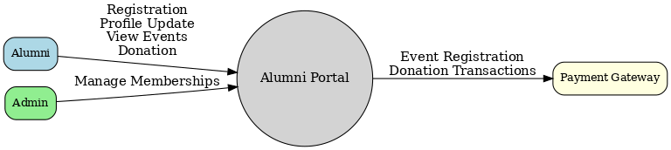
Fig. 3.1: Existing Alumni Portal DFD Model (Context Level)

Description
The Alumni actor interacts with the system for core functions including Registration, Profile Update, Viewing Events, and Donation.
The Admin actor manages memberships, overseeing user access and permissions.
The system communicates with an external Payment Gateway to process financial transactions such as donations or event fees.
All interactions flow into the central Alumni Portal entity, which acts as the single point of contact for all external stakeholders.
Conclusion
The diagram effectively captures the scope of the current system’s external interfaces. However, it reveals a lack of integration for features like mentorship, job boards, or analytics, underscoring the need for a more comprehensive and feature-rich replacement system

1.0

1.0

Proposed System DFD Model (Context Level)
Introduction
This context-level DFD presents the proposed BAUET Alumni Management Portal as a centralized hub that integrates multiple functional modules. It demonstrates how the new system will unify disparate alumni activities under one platform, enhancing engagement and operational efficiency.
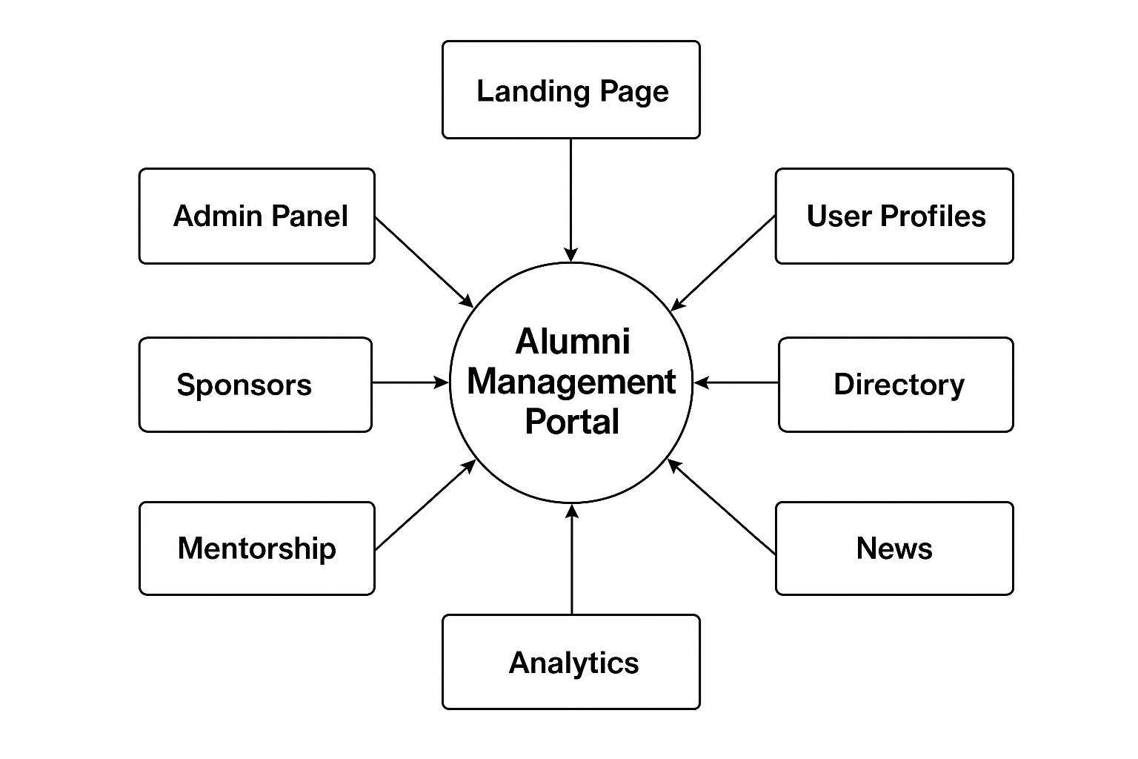

Fig. 3.2: Proposed System DFD Model (Context Level)
Description
The central Alumni Management Portal connects to eight distinct functional areas:

  - Landing Page: Serves as the public entry point.
  - User Profiles: Manages individual alumni data.
  - Directory: Enables searchable alumni listings.
  - News: Publishes institutional updates and success stories.
  - Mentorship: Facilitates structured connections between alumni and students.
  - Analytics: Provides dashboards for tracking engagement and performance.
  - Sponsors: Manages corporate partnerships and advertisements.
  - Admin Panel: Grants administrative control over content, users, and approvals.
  - All modules feed into and draw from the central portal, ensuring seamless data flow and consistent user experience.

Conclusion
This DFD confirms the proposed system’s holistic design, addressing the limitations of the existing portal by integrating essential modules like mentorship, analytics, and sponsor management. It lays the foundation for a unified, scalable, and user-centric platform.

Proposed System DFD Model (Level 1)
Introduction
This Level 1 DFD decomposes the central “Alumni Management Portal” into three major subprocesses: Admin Process, User Management Process, and News/Events Process. It details the data flows between these processes and their respective storage components, providing insight into the system’s internal architecture.
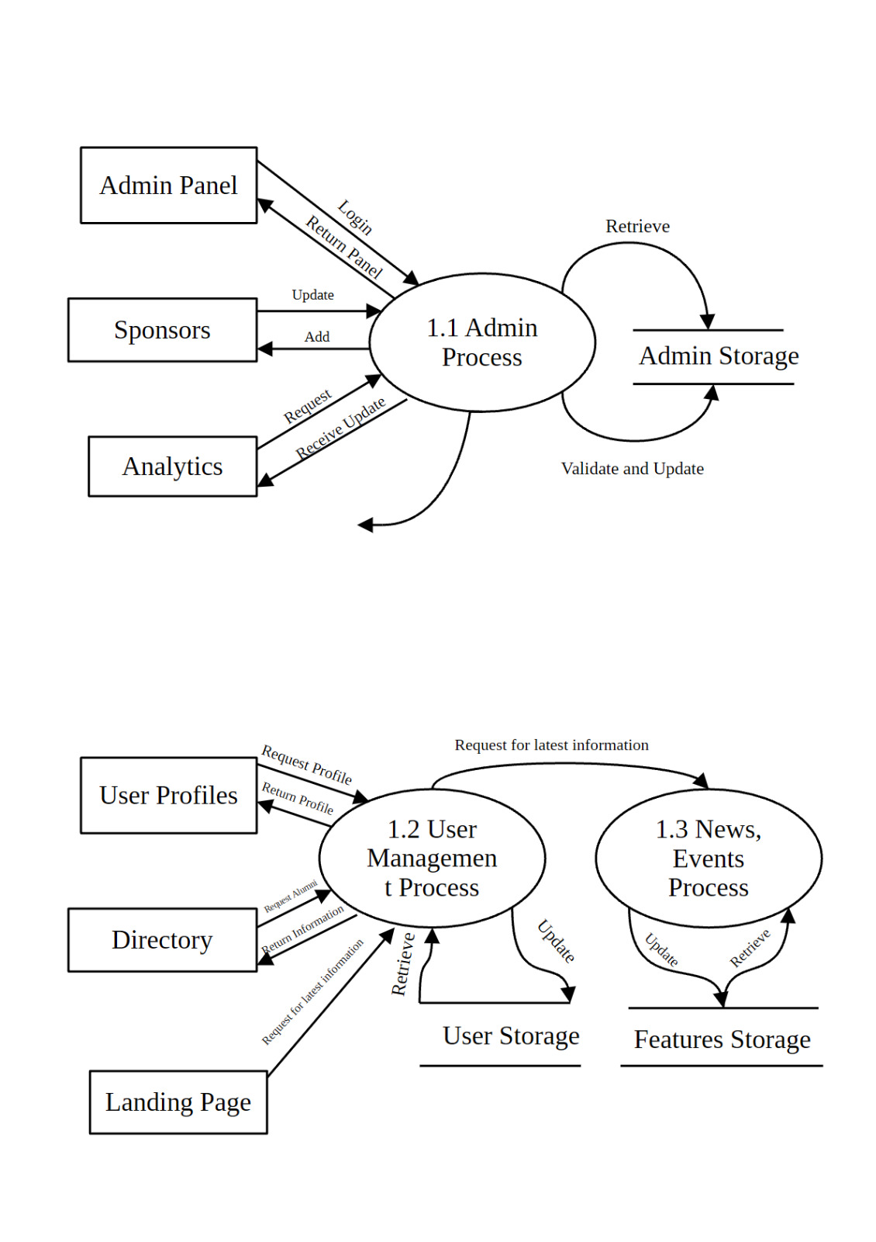

Fig. 3.3: Proposed System DFD Model (Level 1)
Description
1.1 Admin Process:
  - Interacts with the Admin Panel for login and panel access
  - Communicates with Sponsors to manage advertisements and updates
  - Exchanges data with Analytics for reporting and insights
  - Stores and retrieves information from Admin Storage after validation
1.2 User Management Process:
- Handles requests from User Profiles for profile viewing and updates
- Integrates with the Directory for searching and retrieving alumni information
- Responds to requests from the Landing Page for displaying dynamic content
- Maintains data in User Storage, ensuring secure and persistent record keeping

1.3 News, Events Process:
- Manages the creation, update, and retrieval of news articles and event listings
- Stores all content in Features Storage for efficient access and display
- Supports real-time updates and historical archiving of institutional communications

Conclusion
The Level 1 DFD validates the modular structure of the proposed system, ensuring clear separation of concerns while maintaining cohesive data flow. By defining distinct processes for administration, user management, and content delivery, the diagram supports scalability, maintainability, and robust security, key objectives outlined in the project requirements.

- System Use Case Diagram
This diagram shows who interacts with the Alumni Association system. Alumni are the primary users, specializing into Users or Admins after login. Conditional extensions highlight role-based access to features like event management. The backend provides essential data services without initiating user actions

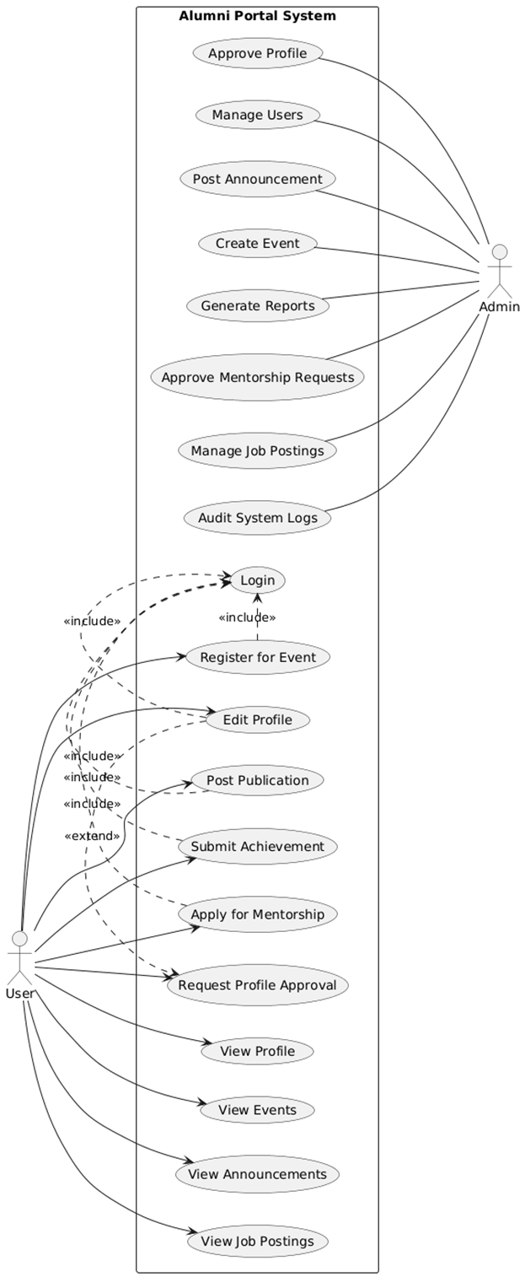
Fig 3.4: Proposed System Use-Case Diagram

Actors

- User (Alumni)
A registered graduate of BAUET who interacts with the portal to manage their profile, explore opportunities, attend events, and connect with peers. They are the primary beneficiary of all core features.

- Admin
A system administrator (often from the Alumni Association or IT department) responsible for content moderation, user verification, reporting, and system maintenance. They ensure data integrity and platform security.

Use Cases

- View Profile
Allows a user to see their own or another alumni’s public profile, including key details like job, batch, and blood group—visible at a glance as per Dean’s requirement.
- Edit Profile
Enables users to update personal, professional, and contact information. Sensitive fields (e.g., biography, address) require admin approval before becoming public.
- Request Profile Approval
Triggered when a user edits restricted profile fields. Submits the updated profile for admin review before it goes live.
- Register for Event
Lets users sign up for alumni-organized events (seminars, reunions, webinars) with automatic reminders and attendance tracking.
- View Events
Displays a dynamic calendar of upcoming and past events with filters by date, type, or organizer.
- View Announcements
Shows official news, updates, or community messages posted by admins or verified alumni.
- Apply for Mentorship
Connects users with experienced alumni mentors based on industry, interest, or career goals—part of the structured mentorship program.
- View Job Postings
Presents a curated list of job opportunities shared by alumni or partner organizations, with AI-powered matching.
- Post Publication
Allows users to share scholarly articles, blog posts, or professional work with title, publisher, and link.
- Submit Achievement
Lets alumni log awards, certifications, or notable accomplishments for display on their profile.
- Login
Authenticates users via email/password or SSO (e.g., Google). Required for all profile-editing and submission actions.
- Approve Profile
Admin reviews and approves or rejects profile edits that affect public visibility, ensuring data accuracy and preventing abuse.
- Manage Users
Admin can view, suspend, or verify alumni accounts and toggle roles (e.g., feature alumni, assign mentor status).

- Create Event
Admin schedules and configures new events with descriptions, dates, and registration settings.
- Generate Reports
Admin exports analytics on user engagement, event attendance, job activity, or system usage for institutional reporting.
- Approve Mentorship Requests
Admin validates and facilitates mentor-mentee pairings to maintain program quality.
- Manage Job Postings
Admin reviews, approves, or removes job listings to ensure legitimacy and relevance.
- Audit System Logs
Admin monitors user activity trails (logins, edits, sign-ups) for security and compliance, as required by BAUET policy.

Relationships

- <<include>> Login
Indicates that authentication is a mandatory prerequisite for secure actions like editing profile, posting content, or applying for mentorship.

- <<extend>> Request Profile Approval
Represents an optional, conditional flow: only triggered when a user modifies sensitive profile fields that require admin oversight.

Conclusion
The use case diagram effectively captures the core functionalities of the BAUET Alumni Portal by clearly delineating the roles and interactions of its two main actors: User (Alumni) and Admin. It highlights essential user-driven features such as profile management, event registration, job exploration, and mentorship, while also reflecting administrative responsibilities like content moderation, user verification, and system auditing. The use of «include» and «extend» relationships ensures a clean separation between mandatory authentication flows and conditional, approval-based actions. Overall, the diagram provides a concise yet comprehensive blueprint of system behavior, aligning with BAUET’s requirements for security, usability, and community engagement.

- System Class Diagram
The class diagram for the BAUET Alumni Portal presents a structured and object-oriented view of the system’s core data models and their relationships. The diagram centers around the UserProfile class as the primary entity, intentionally consolidating user identity without a separate User model, as per specification. This design decision reflects the portal’s focus on alumni as complete professional profiles rather than abstract accounts.

Each associated entity, such as Education, Experience, Publication, Achievement, Job, and EventInfo, is modeled with composition (denoted by a filled “holo” diamond), indicating strong ownership: these records have no standalone meaning outside a user’s profile and are deleted if the profile is removed. In contrast, the Department class is linked via a simple association, acknowledging its independent existence as a shared institutional entity across multiple alumni. All attributes are marked private (-) to enforce encapsulation and data integrity, while all operations (e.g., update_profile(), register_for_event()) are public (+), defining the allowed interactions with each class.

Fig 3.4: Proposed System Class Diagram

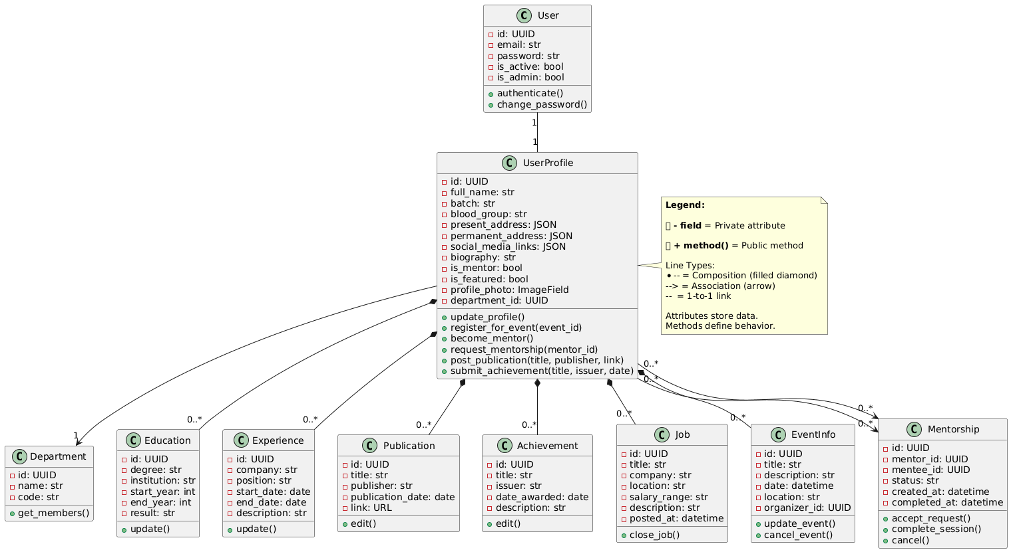

Fig 3.5: Proposed System Class Diagram

Class Descriptions
- UserProfile
The central entity representing a verified BAUET alumni. Contains personal, professional, contact, and social information, and serves as the owner of all profile-related data (education, experience, etc.).
- Department
Represents an academic department at BAUET (e.g., Computer Science & Engineering). Shared across multiple users and exists independently of any individual profile.
- Education
Stores a user’s academic background, including degree, institution, years attended, and GPA. Tied exclusively to one UserProfile.
- Experience
Captures a user’s professional work history, including company, role, duration, and key responsibilities. Owned by and cannot exist without a UserProfile.
- Publication
Represents scholarly or professional articles, blogs, or reports authored by the user. Includes title, publisher, date, and link for verification and visibility.
- Achievement
Records awards, certifications, or notable recognitions earned by the alumni. Includes issuer, date, and description to highlight professional milestones.
- Job
Represents job opportunities posted by the user (e.g., for hiring or sharing). Includes role details, company, location, and description—owned by the posting user.
- EventInfo
Stores details of events (reunions, webinars, etc.) organized by a user. Includes title, date, location, and description—deleted if the organizer’s profile is removed.
- Post Announcement
Admin creates and publishes official announcements visible to all users.
- MentorShip
The Mentorship class models structured peer guidance by capturing mentor-mentee pairings with status tracking and timestamps. It enables alumni to serve as both mentors and mentees through bidirectional associations with UserProfile, supporting BAUET’s professional development goals.

Methods (All Public)
All behaviors are exposed via public methods (+), defining how objects interact with the system.
- UserProfile
- + update_profile()
- + register_for_event(event_id)
- + apply_for_mentorship()
- + post_publication(title, publisher, link)
- + submit_achievement(title, issuer, date)

- Department
- + get_members() – Returns all alumni in this department

- Education, Experience, Publication, Achievement
- + update() or + edit() – Modify record details
- Job()
- + close_job() – Mark job as inactive

- Job
- + close_job() – Mark job as inactive

- EventInfo
- + update_event()
- + cancel_event()

- Mentorship
- + create_request(mentee_id, mentor_id, message, focus_areas)
- + accept_request()
- + reject_request()
- + cancel()
- + add_progress_note(note: str)

Relationships (Class-to-Class)
All relationships reflect real-world ownership and association logic.
- Composition (◆ — Strong Ownership)
  - UserProfile ◆—— Education
→ Education records cannot exist without a user profile.
  - UserProfile ◆—— Experience
→ Work history is owned by the user.
  - UserProfile ◆—— Publication
→ Publications are user-created content.
  - UserProfile ◆—— Achievement
→ Achievements are personal milestones tied to the user.
  - UserProfile ◆—— Job
→ Jobs are posted by the user (as opportunities or personal roles).
  - UserProfile ◆—— EventInfo
→ Events are organized by the user.

- Association (→ — Independent Reference)
  - UserProfile → Department
→ A user belongs to one department, but the department exists independently (e.g., multiple users in “CSE”).
→ Deleting a user does not affect the department.
  - UserProfile —— Mentorship
→ Alumni can serve as either mentor or mentee in structured mentorship
managed through the portal.

Conclusion
The class diagram for the BAUET Alumni Portal presents a clean, user-centric, and well-structured domain model that accurately reflects the system’s functional and organizational requirements. Centered around the UserProfile class, the design consolidates all alumni-related data, including education, experience, publications, achievements, jobs, and events, under a single, unified identity, ensuring data coherence and ease of management.
Relationships are modeled with precision: composition (◆) is correctly used for all user-owned entities (e.g., Education, Experience), reflecting their lifecycle dependency on the profile, while a simple association (→) links UserProfile to the independently existing Department. The inclusion of the Mentorship class, connected via dual associations, supports the portal’s core requirement that alumni can fluidly act as both mentors and mentees without requiring inheritance or role-based subclasses.
All attributes are appropriately marked as private (-) and all behaviors as public (+), enforcing encapsulation and controlled access in alignment with secure software design principles. The model also integrates seamlessly with Django’s authentication system through a 1-to-1 link between User and UserProfile, maintaining separation of concerns while enabling extensibility.
In summary, this class diagram not only fulfills the documented needs of the BAUET Alumni Portal but also lays a scalable, maintainable, and logically consistent foundation for future enhancements, such as analytics, messaging, or event RSVPs, without compromising clarity or integrity.

Introduction
The database system has been designed to efficiently manage and organize alumni-related information in a structured and reliable manner. It serves as a centralized platform that connects students, graduates, mentors, and departments within an institution, ensuring smooth information exchange and long-term engagement. The system stores comprehensive data about each user, including personal details, academic records, professional experiences, achievements, and publications. This allows the institution to maintain a detailed and accessible alumni directory that can be utilized for academic, professional, and networking purposes.
In addition to personal and academic records, the system also manages various interactive functionalities. These include event organization, mentorship programs, job postings, and news publication modules, all of which help foster continuous communication between current students and alumni. Each of these components is designed to enhance the alumni community by creating opportunities for collaboration, career development, and mentorship. By integrating these features, the database not only preserves historical and institutional data but also provides a dynamic environment for ongoing engagement and resource sharing among members of the academic network.
The system’s design follows a relational database model, ensuring consistency, accuracy, and interconnectivity among different entities such as users, departments, and their associated records. Relationships between entities like user–department, user–education, and user–experience allow seamless data referencing and retrieval, reducing duplication and improving database efficiency. The inclusion of timestamps and foreign key constraints ensures data integrity and enables effective record tracking and auditing. Moreover, attributes like is_active, is_mentor, and is_approved provide role-based functionalities that enhance data control and system security. The flexible structure also allows for future scalability, supporting new features or entities as institutional needs evolve.
Overall, this alumni management database system provides a comprehensive, user-friendly, and secure platform that bridges the gap between students, faculty, and alumni. It creates a digital ecosystem that promotes lifelong institutional relationships and professional networking. By integrating academic achievements, professional experiences, and interactive activities within one database, the system strengthens institutional connectivity and supports a sustainable framework for continuous engagement. This efficient database structure serves as a cornerstone for academic management, alumni collaboration, and organizational growth in the long run.

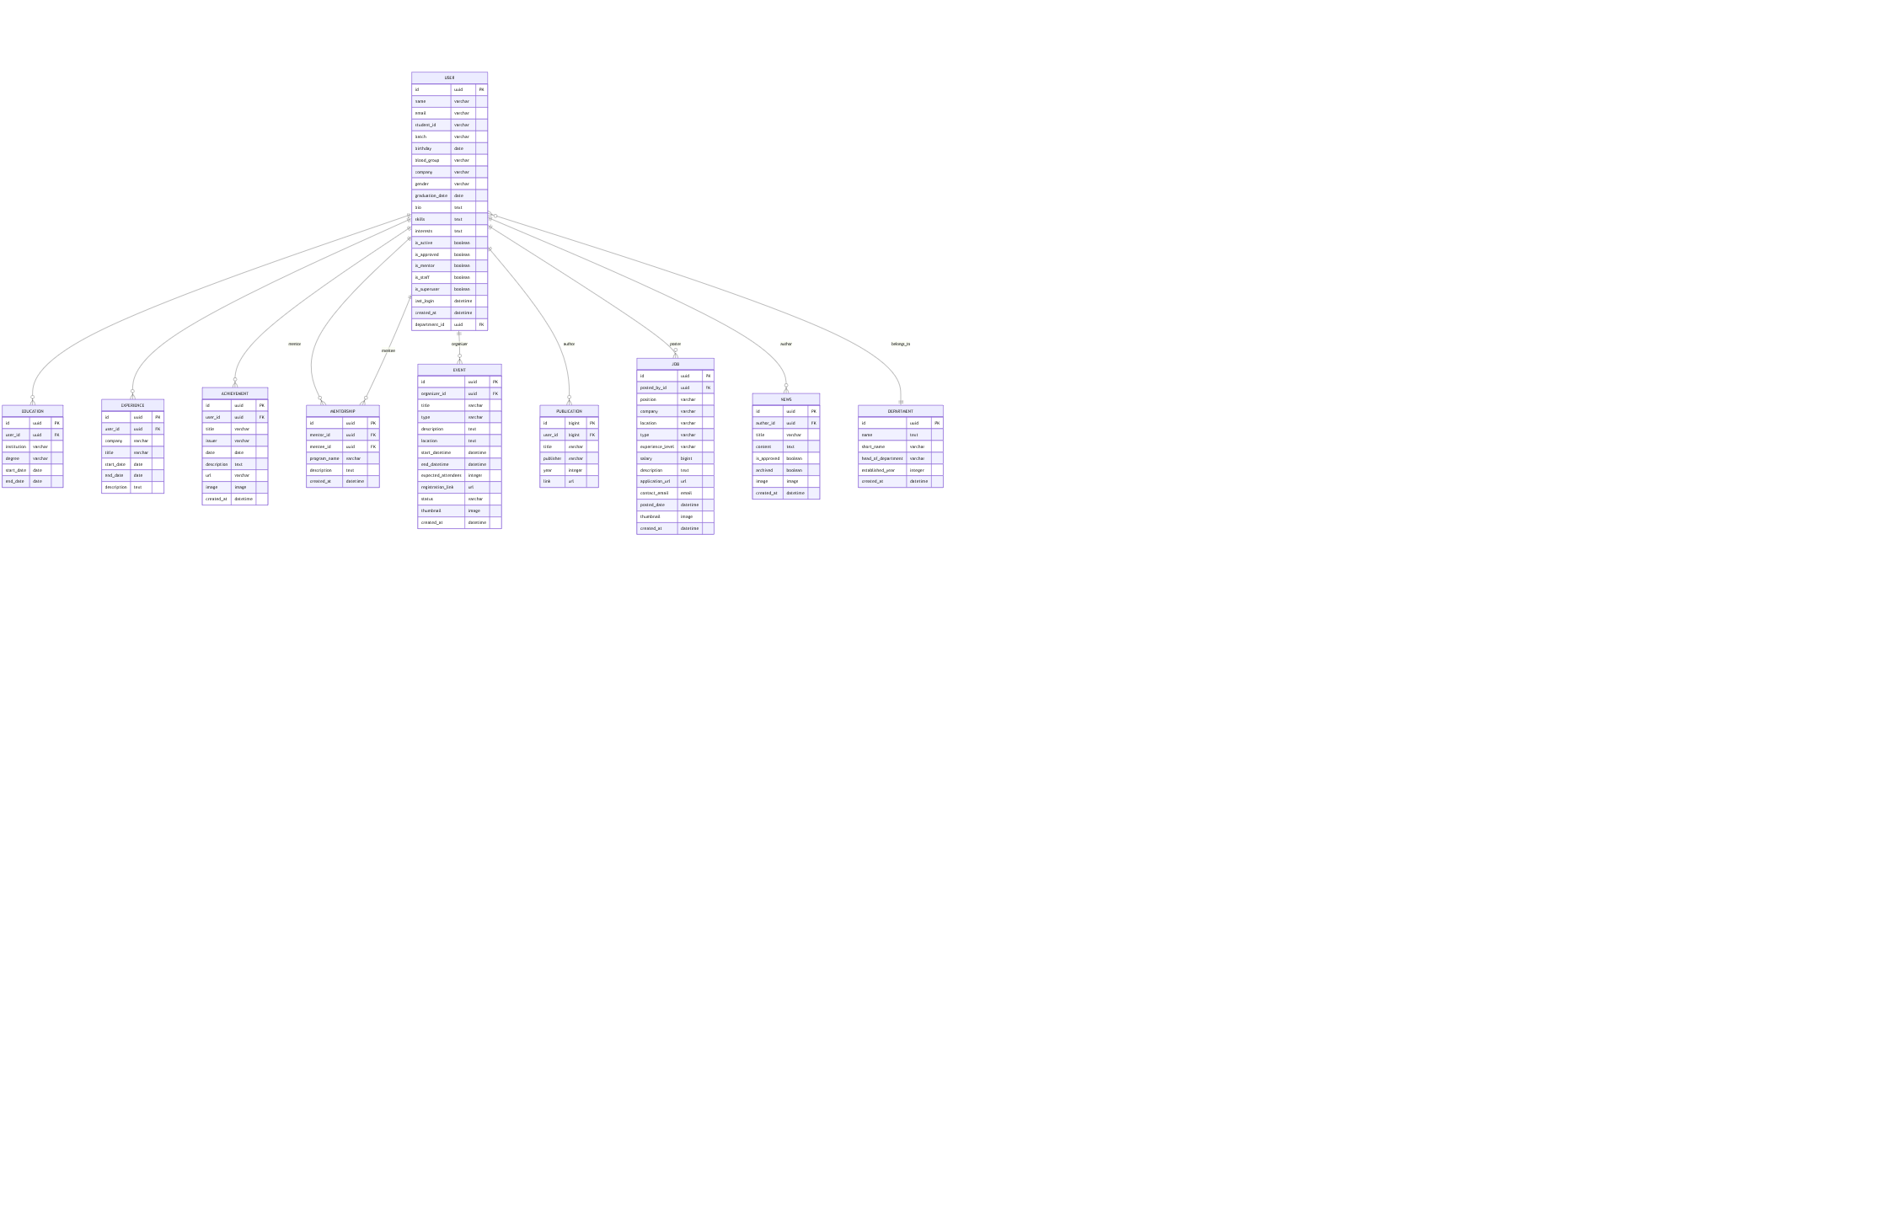
Fig 3.6: Proposed System ER Diagram

Description

Entities and Their Attributes
- USER
Primary Key: id
Attributes: id (uuid), name (varchar), email (varchar), student_id (varchar), batch (varchar), birthday (date), blood_group (varchar), company (varchar), gender (varchar), graduation_date (date), bio (text), skills (text), interests (text), is_active (boolean), is_approved (boolean), is_mentor (boolean), is_staff (boolean), is_superuser (boolean), last_login (datetime), created_at (datetime), department_id (uuid) - FK.
This table stores detailed personal and academic information of each user and links them to a specific department.

- EDUCATION
Primary Key: id
Attributes: id (uuid), user_id (uuid) - FK, institution (varchar), degree (varchar), start_date (date), end_date (date), description (text).
It records users’ educational qualifications and institutions attended.

- EXPERIENCE
Primary Key: id
Attributes: id (uuid), user_id (uuid) - FK, company (varchar), title (varchar), start_date (date), end_date (date), description (text), url (varchar), image (image), created_at (datetime).
It holds users’ professional experience details, including their workplace, job titles, and employment period.

- ACHIEVEMENT
Primary Key: id
Attributes: id (uuid), user_id (uuid) - FK, title (varchar), issuer (varchar), date (date), description (text), url (varchar), image (image), created_at (datetime).
This table maintains users’ academic or professional achievements such as awards or certifications.

- MENTORSHIP
Primary Key: id
Attributes: id (uuid), mentor_id (uuid) - FK, mentee_id (uuid) - FK, program_name (varchar), description (text), created_at (datetime).
It defines mentorship relationships between users, where one acts as a mentor and another as a mentee.

• PUBLICATION
Primary Key: id
Attributes: id (bigint), user_id (uuid) - FK, title (varchar), publisher (varchar), year (integer), link (url).
Contains publication data authored or co-authored by users.
• JOB
Primary Key: id
Attributes: id (uuid), posted_by_id (uuid) - FK, position (varchar), company (varchar), location (varchar), type (varchar), experience_level (varchar), salary (bigint), description (text), application_url (url), contact_email (email), posted_date (datetime), thumbnail (image), created_at (datetime).
Represents job postings shared by alumni or administrators.
• NEWS
Primary Key: id
Attributes: id (uuid), author_id (uuid) - FK, title (varchar), content (text), is_approved (boolean), attached (boolean), image (image), created_at (datetime).
Used to post and manage news or announcements within the alumni system.
• DEPARTMENT
Primary Key: id
Attributes: id (uuid), name (text), short_name (varchar), head_of_department (varchar), established_year (integer), created_at (datetime).
Represents various academic departments to which users are associated.

Primary and Foreign Key Differentiation
USER
- Primary Key (PK): id
- Foreign Key (FK): department_id → references DEPARTMENT(id)
EDUCATION
- Primary Key (PK): id
- Foreign Key (FK): user_id → references USER(id)
EXPERIENCE
- Primary Key (PK): id
- Foreign Key (FK): user_id → references USER(id)
ACHIEVEMENT
- Primary Key (PK): id
- Foreign Key (FK): user_id → references USER(id)

PUBLICATION
- Primary Key (PK): id
- Foreign Key (FK): user_id → references USER(id)

EVENT
- Primary Key (PK): id
- Foreign Key (FK): organizer_id → references USER(id)

.

JOB
- Primary Key (PK): id
- Foreign Key (FK): posted_by_id → references USER(id)

NEWS
- Primary Key (PK): id
- Foreign Key (FK): author_id → references USER(id)

MENTORSHIP
- Primary Key (PK): id
- Foreign Keys (FKs):
mentor_id → references USER(id)
mentee_id → references USER(id)

DEPARTMENT
- Primary Key (PK): id
- Foreign Keys (FKs): None

Conclusion
The database schema efficiently captures the core components of an alumni management system, linking users to their educational, professional, and social activities. Each entity plays a unique role in ensuring proper data organization and relationship integrity. By combining personal, academic, and professional information, the system supports smooth communication, mentorship, event coordination, and career networking between students, alumni, and faculty members. This structured relational design ensures scalability, consistency, and efficient data retrieval for future system enhancements.

Cost–Benefit Analysis
Introduction
Cost–Benefit Analysis (CBA) is a systematic process used to evaluate the financial viability of a project by comparing its total expected costs against its anticipated benefits. Traditionally applied in commercial or government-funded initiatives, CBA helps determine whether a system delivers positive return on investment (ROI).

Description
In the case of the BAUET Alumni Portal, a formal cost–benefit analysis was not performed, as the project is fundamentally a social and institutional initiative, not a revenue-generating product. The portal aims to strengthen community bonds, enhance alumni engagement, support mentorship, and foster institutional pride, with success measured in social impact, not profit.

The development was carried out primarily through academic effort and open-source technologies (e.g., Django, PostgreSQL, Vercel), minimizing direct monetary costs. While operational expenses (hosting, maintenance) exist, they are absorbed by the university as part of its long-term investment in alumni relations, similar to maintaining a physical alumni office or organizing reunion events.

Key benefits, such as improved networking, career support for graduates, increased visibility of alumni achievements, and streamlined communication, are intangible but institutionally valuable. These outcomes align with BAUET’s mission of service, leadership, and lifelong community, making traditional financial metrics inadequate for evaluation.

Conclusion
Given its non-commercial nature and focus on social value, the BAUET Alumni Portal prioritizes impact over income. The absence of a formal cost–benefit analysis is both intentional and appropriate; the true “return” lies in a more connected, supportive, and engaged alumni ecosystem that benefits current students, graduates, and the university as a whole.

